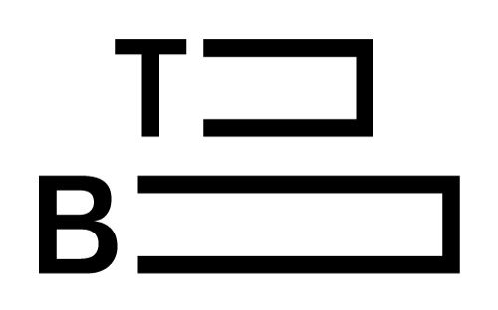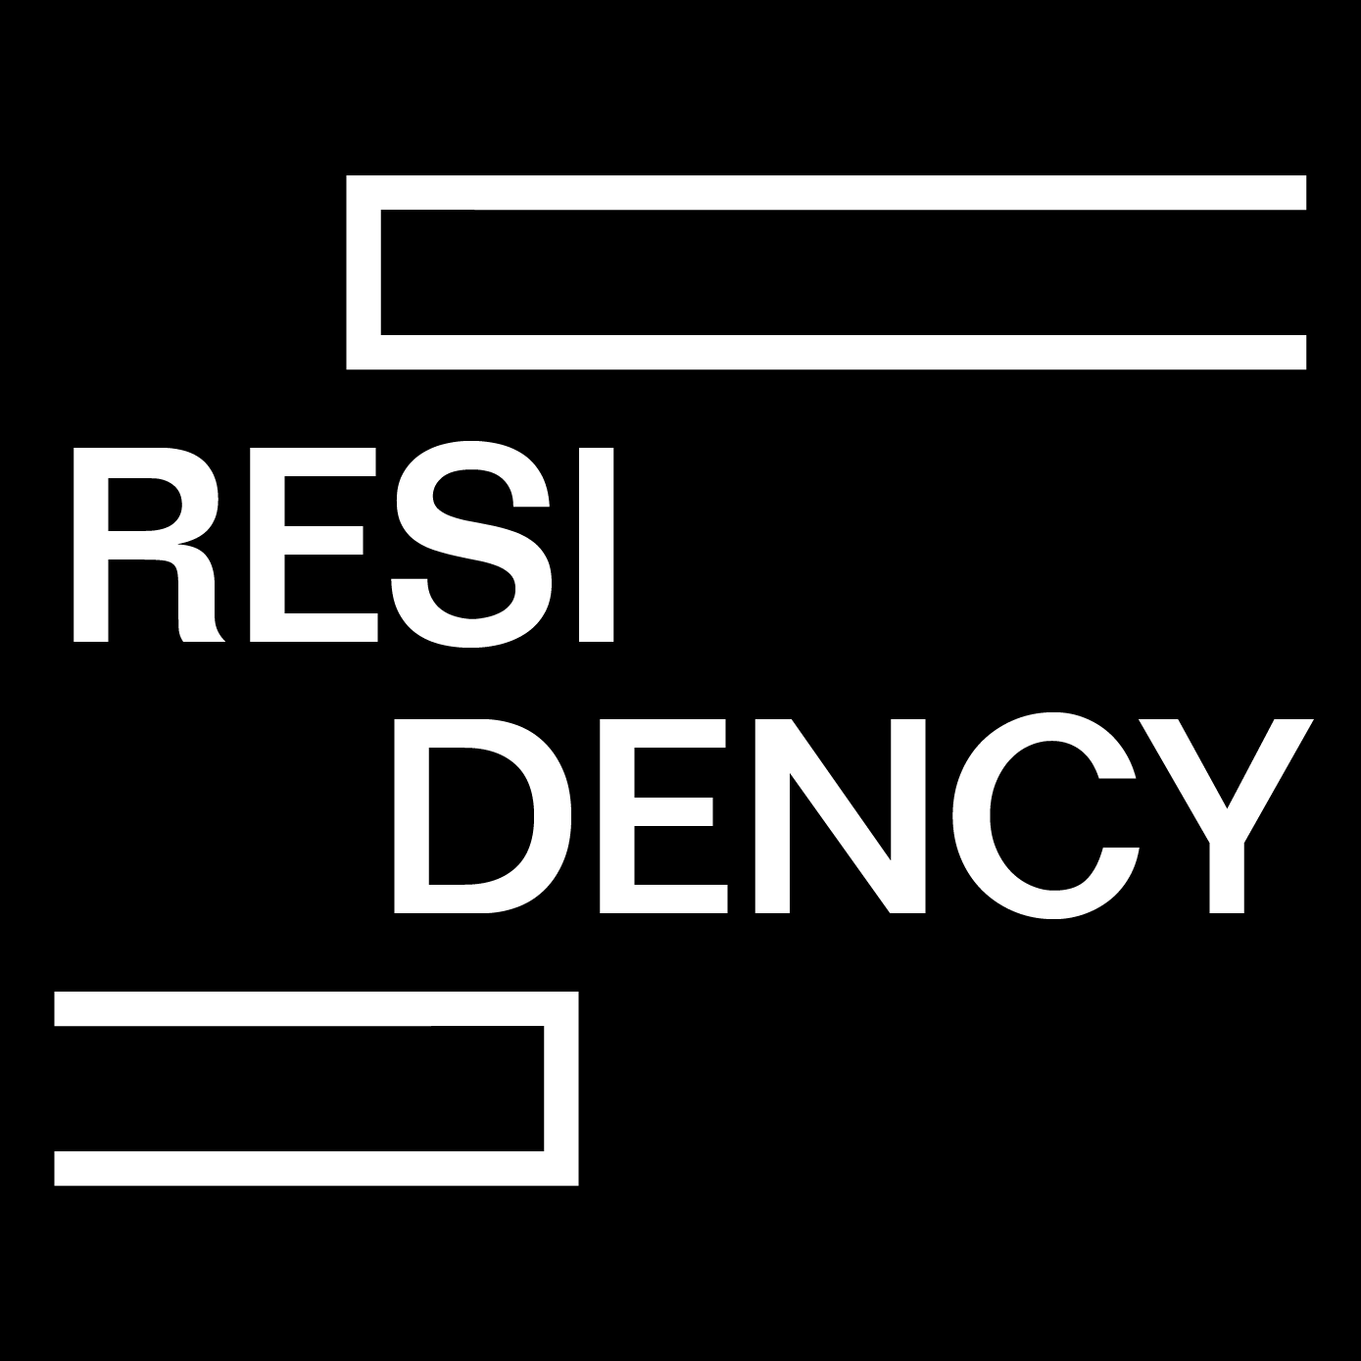
Application for Project Proposal Residency
Deadline: 30th July 2016
Please send all the documentation to: info@theblankresidency.it
Period: from 18th October to 20th November 2016

Family name:

First name:

Nationality:

Date of birth:

Address:

Telephone number:

Email address:

Website:

Artist statement
(max. 200 words)

Letter of intent
(max. 300 words)

Project Proposal (max. 300 words)

Attachments | CV □ Portfolio □ Additional material such as articles, publications, (if available) etc. □ Images or videos □

